**BFS VS DFS**

BFS which stands for ( Breadth First Search) is a technique used for finding the shortest path in a graph by visiting each node and its adjacent from the top until the root while DFS which stands for ( Depth First Search) is an edge based technique that finds the shortest path in the graph by going to the tree root first instead of last .

When do we use BFS and DFS ?

Well the answer isn't that direct it depends on the statics on the graph solutions . If most of the solutions in a tree is in the middle not root then we use BFS if most of the solutions are and deep in the roots then we use DFS. But usually we use DFS because of these BFS issues . If the tree is very wide BFS will take too much memory and it will be impractical and also to use BFS you need to have a shared datastructure between threads which is bad.

For example :

BFS DFS

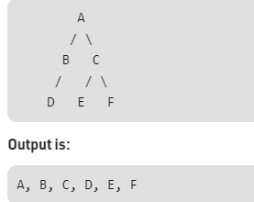 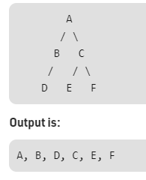

If the solution we wanted was D then DFS would have gotten it faster If the solution was C BFS would have gotten it faster.